I can count to 10 on my figures without taking my eye off the job. Perhaps I use the beads and the string to make a strand of 10 beads. This way every time I count from 1 to 10, utilizing the fingers of my hands, I move one of the beads along. This allows me to count up to hundred without losing count. After the counting process is completed, I would use two sticks to record the account. On one stick, I would carve a grove all the way around. One for every bead I had counted, therefore each grove would mark 10 sheep. On another stick, I would mark straight notches to record the counts on my fingers, the ones that were not transferred to the beads. The owner would take the two sticks as the record of his stock.

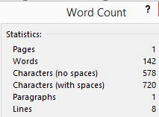

11/17/2013